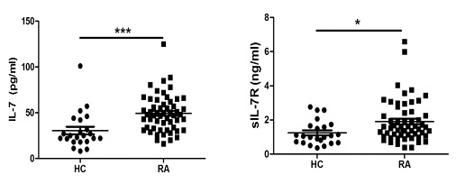

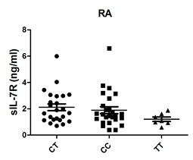Data 22.tif

**RA HC**

CT vs CC, P = 0.5403 CT vs CC, P = 0.0292

CT vs TT, P = 0.0688 CT vs TT, P = 0.2427

CC vs TT, P = 0.1914 CC vs TT, P = 0.7470